**This assignment is based on request and response of ping and reverse type.**

There are 3 php page are used along with xsd folder for validating the xml request.

1. **index.php :**

In this page user can enter Sender, Recipient, Reference, Message & Request type either Ping or Reverse and also Other

for checking wrong xml validation with xsd file.

1. **receive.php:**

This page receive xml with post method and checking the input request and validating with xsd.

1. **UtilityClass.php:**

This is utility class used for other php pages. It consist of two functions.

* Function to generate request xml by passing request type.
* Function to generate response xml by passing request type, message, sender, recipient, reference and reverse, reverse parameter is used for reverse response and also for error code.

**How to run this Project?**

* Paste the project in C:\xampp\htdocs folder.
* Use Xampp control panel to run the project.

**Tool used:**

* Visual Studio Code and Xampp control panel.

**Technology used:**

* Php, Html, Bootstrap

**User Manual**

1. **Ping Request:** Enter value as below and click on Send Request button

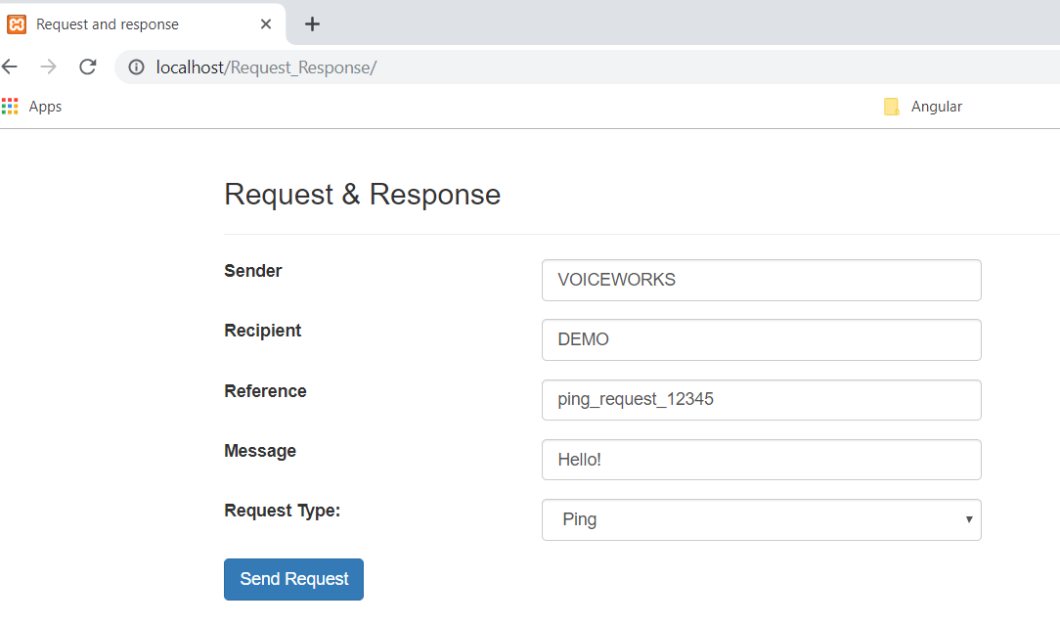

**Response receive as below:**

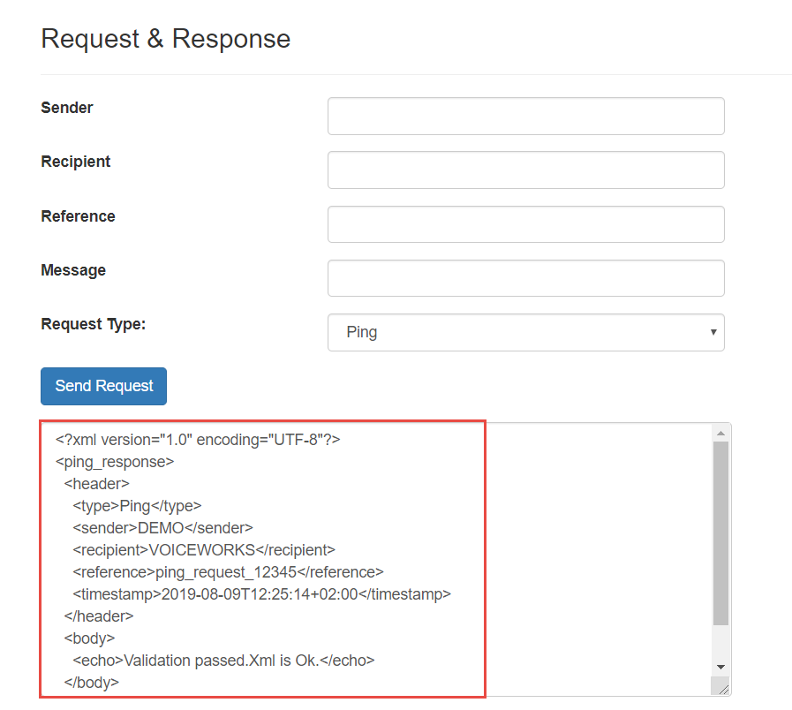

1. **Reverse Request:** Enter value as below and click on Send Request button

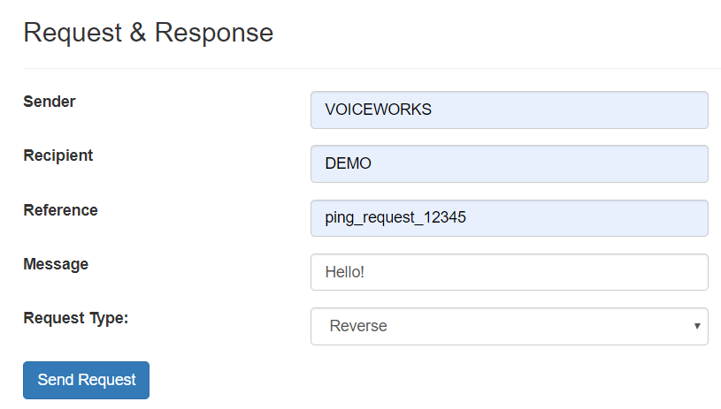

**Response receive as below:**

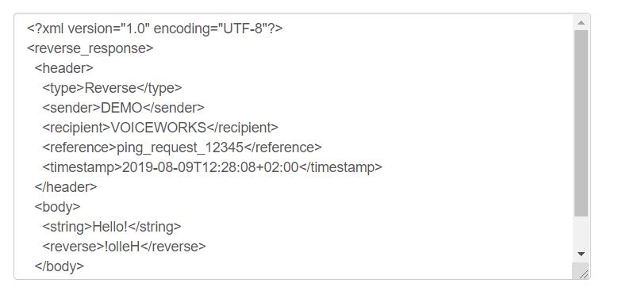

1. **Other Request:** Enter value as below and click on Send Request button

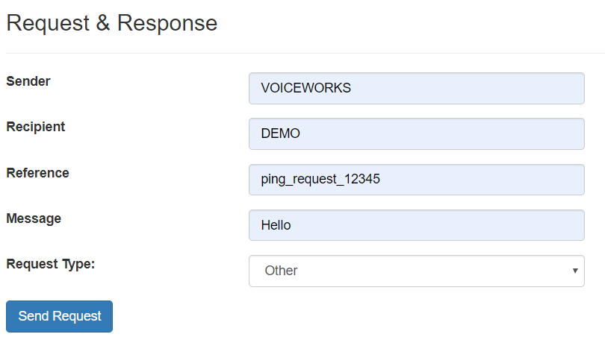

**Response receive as below:**

